SCTR’s Pune Institute of Computer Technology

(PICT) Pune

AN
INTERNSHIP REPORT
ON

Smart Transformer Health Monitoring System using ESP32

SUBMITTED BY
Name: Payal Chandoba
Class: TE 5
Roll no: 32209

Under the guidance of
Dr. R. G. Yelalwar


DEPARTMENT OF ELECTRONICS AND TELECOMMUNICATION ENGINEERING
ACADEMIC YEAR 2025-26



DEPARTMENT OF ELECTRONICS AND TELECOMMUNICATION ENGINEERING

SCTR’s Pune Institute of Computer Technology (PICT), Pune
Maharashtra 411043

CERTIFICATE

This is to certify that the internship report titled
“Smart Transformer Health Monitoring System using ESP32 "

Submitted by

Payal Chandoba

TE400050043

has satisfactorily completed the curriculum-based internship under the guidance of Dr. R. G. Yelalwar towards the partial fulfillment of third year Electronics and Telecommunication Engineering Semester VI, Academic Year 2025-26 of Savitribai Phule Pune University.

Dr. R. G. Yelalwar Mrs. Ankita Patel Dr. G. S. Mundada
Internship Guide Internship Coordinator Head of the Department
(E&TC Engg.)

Place: Pune
Date:

Acknowledgement

It gives me great pleasure in presenting the internship report on “Smart Transformer Health Monitoring System using ESP32.” I would like to take this opportunity to express my sincere gratitude to my internship guide, Dr. R. G. Yelalwar, for providing valuable guidance, constant encouragement, and kind support throughout the internship. His insightful suggestions and continuous motivation greatly contributed to the successful completion of this project.
I am also thankful to the Head of the Electronics and Telecommunication Engineering Department, Dr. G. S. Mundada, for her indispensable support and encouragement during the internship work. I would like to express my heartfelt gratitude to the Department Internship Coordinator, Mrs. Ankita Patel, for her continuous guidance, support, and timely resolution of doubts related to the internship process. I also extend my sincere thanks to the Lab Assistant for providing technical support, assistance in handling equipment, and cooperation during the practical work, which significantly contributed to the successful completion of this project.
Lastly, I thank everyone who directly or indirectly contributed to the successful completion of this internship.

Contents

 | List of Figures | i
 | List of Tables | i
1 | Title | 1
2 | Introduction | 1
3 | Problem Statement | 1
4 | Objectives and scope | 2
5 | Methodological details | 3
6 | Usage of Modern engineering tools | 8
7 | Outcome/ results of internship work | 9
8 | Internship Logbook | 12
9. | Internship Offer letter | 15
10. | Certificate of Completion | 17

List of figures

Sr.No. | Name of the figure | Page No.
1. | Flow Diagram of Smart Transformer Health Monitoring System | 4
2. | Complete Circuit Schematic of ESP32-Based Monitoring System | 5
3. | Breadboard testing of the sensor | 9
4. | Hardware Prototype of IoT-Based Transformer Health Monitoring System | 10
5. | Live Monitoring on the Blynk app | 10
6. | ThingSpeak Cloud Dashboard Showing Transformer Health Parameters | 11
7. | Historical Transformer Parameter Data Stored Excel Export | 11

List of tables

Sr.No. | Name of the figure | Page No.
1. | Threshold Values | 7

- Title
Smart Transformer Health Monitoring System using ESP32

- Introduction
This report presents the work carried out during my internship on the development of the Smart Transformer Health Monitoring System using ESP32. The project focuses on designing a smart monitoring system capable of continuously observing important transformer parameters such as temperature, current, and oil level. The system is developed to improve transformer safety, reliability, and efficiency by detecting abnormal conditions in real time.
During the internship, I learnt about the embedded system ,sensor and IoT also worked on sensor interfacing, circuit design, hardware integration . The system was developed using components such as the ESP32 microcontroller, LM35 temperature sensor, ACS712 current sensor, and relay module. I also gained hands-on experience in programming using PlatformIO, debugging circuits, and testing system performance under different load conditions.
The internship enhanced my technical knowledge in embedded systems and IoT (Internet of Things) applications, while also improving my problem-solving skills and practical understanding of real-time monitoring systems.
- Problem statement
Power transformers play a crucial role in electrical power distribution systems, and their continuous operation is necessary to ensure a reliable power supply. However, transformers are often subjected to varying load conditions, which may lead to faults such as overheating, excessive current flow, insulation failure, and oil level reduction. These issues can result in system failure, power outages, costly repairs, and reduced transformer lifespan.
Traditional transformer monitoring methods mainly rely on manual inspection, which is time-consuming, inefficient, and unable to detect faults in real time. In addition, conventional systems do not maintain proper historical data records, making it difficult to analyze past performance, identify trends, and predict possible failures.
Therefore, there is a need for an automated and real-time transformer health monitoring system that can continuously monitor important transformer parameters such as temperature, current, and oil level, while also storing historical data for analysis. Such a system can provide timely alerts during abnormal conditions, help predict potential faults, and improve the overall reliability, safety, and efficiency of the power system.
- Objectives and scope
4.1. Objective
• To design an IoT-based transformer monitoring system.
• To measure transformer temperature using LM35 sensor.
• To measure transformer load current using ACS712 sensor.
• To measure oil level using ultrasonic sensor.
• To display real-time data using Blynk platform.
• To store historical data using ThingSpeak.
• To generate SMS alerts using GSM module.
• To automatically disconnect load during overload using relay.
4.2. Scope
    - Real-Time Monitoring : The system continuously monitors transformer parameters such as temperature, current, and oil level using sensors and displays real-time values through IoT platforms.
- Remote Monitoring : Transformer parameters can be monitored remotely using the Blynk mobile application, allowing users to access live data from any location.
- Automatic Fault Detection : The system detects abnormal conditions based on predefined threshold values and identifies faults such as overheating, overload, and low oil level.
- SMS Alert System : GSM module sends SMS notifications to users during abnormal transformer conditions, ensuring quick response to faults.
- Load Protection System : Relay automatically disconnects the load when unsafe conditions are detected, protecting the transformer from damage.
- Historical Data Storage : Sensor data is stored in ThingSpeak cloud platform, enabling historical analysis and performance tracking.
- Industrial Applications : The system can be used in industrial transformer monitoring, power distribution systems, and smart grid applications.

- Methodological details

The development of the Smart Transformer Health Monitoring System followed a structured methodology consisting of requirement analysis, system design, hardware implementation, software development, integration of IoT platforms, testing, and final deployment. The system continuously monitors transformer parameters such as temperature, current, and oil level and generates alerts during abnormal conditions.

5.1 Requirement Analysis:
In this phase, the system requirements were identified based on transformer monitoring needs. The key parameters selected for monitoring were temperature, load current, and oil level, as these directly affect transformer health and performance.
The following requirements were identified:
- Temperature measurement using LM35 temperature sensor
- Current measurement using ACS712 current sensor
- Oil level measurement using Ultrasonic sensor
- Microcontroller selection (ESP32) for processing sensor data
- Real-time monitoring using Blynk
- Historical data storage using ThingSpeak
- Fault alert generation using GSM module and Telegram Bot
- Load protection using Relay module
This phase ensured proper component selection and system feasibility.

5.2 System Design
In this stage, the overall architecture of the system was designed. All sensors were connected to the ESP32 microcontroller, which acts as the central processing unit of the system. The ESP32 collects sensor data, processes it, and sends the information to cloud platforms.
The system also includes:
- Relay for load control
- Buzzer for audible alert
- GSM module for SMS notification
- Cloud platforms for monitoring and data storage
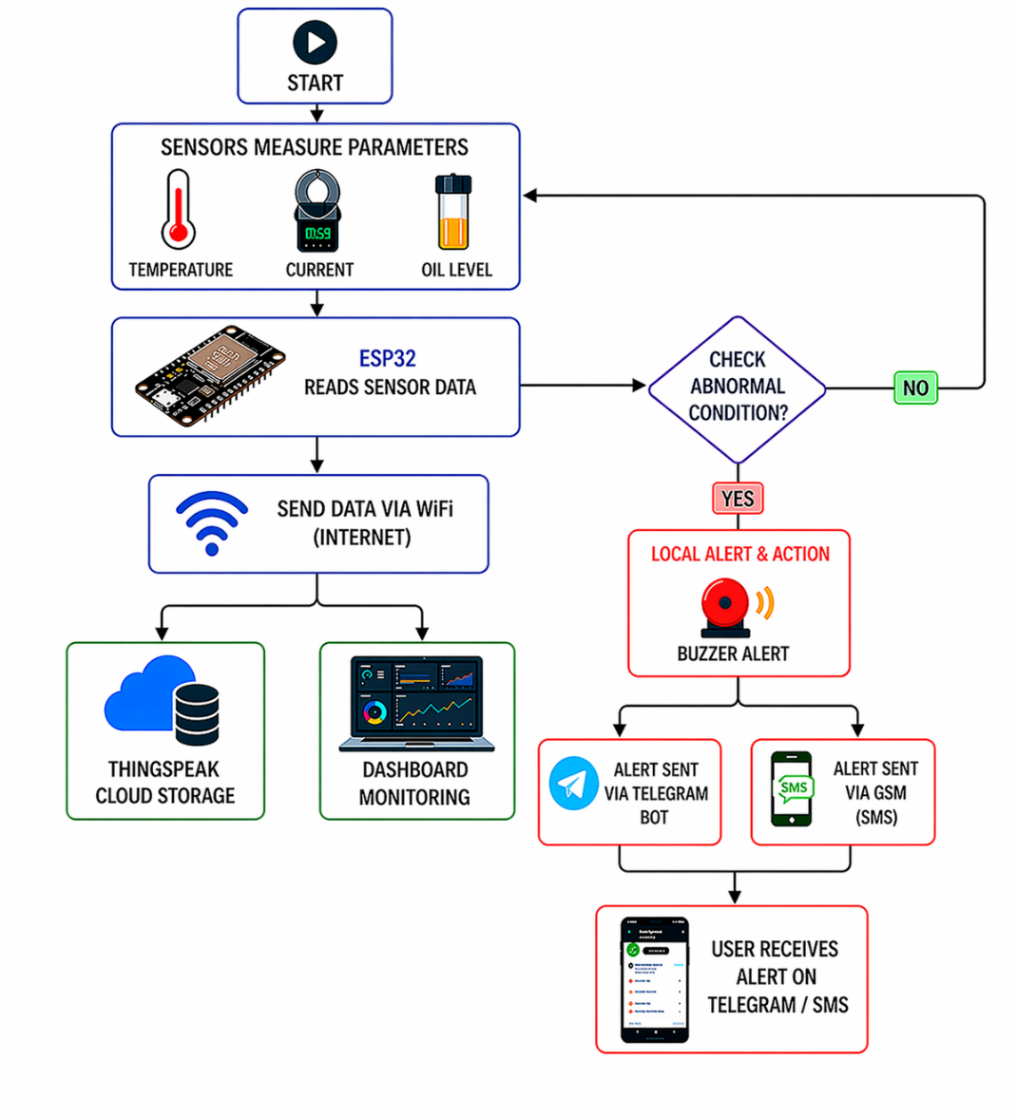
Fig 5.1: Block Diagram of Smart Transformer Health Monitoring System

5.3 Hardware Implementation
In this phase, all hardware components were connected according to the system design. Sensors were interfaced with ESP32 analog and digital pins. Proper power supply circuits were implemented to ensure stable operation of components.
The hardware includes:
- ESP32 microcontroller as the main controller
- LM35 sensor for temperature measurement
- ACS712 sensor for current measurement
- Ultrasonic sensor for oil level detection
- Relay module for load control
- Buzzer for fault alert
- SIM800L GSM module for SMS alert
- Transformer load setup using bulb load
Voltage divider circuits were used where necessary to ensure safe voltage levels for ESP32 analog inputs.

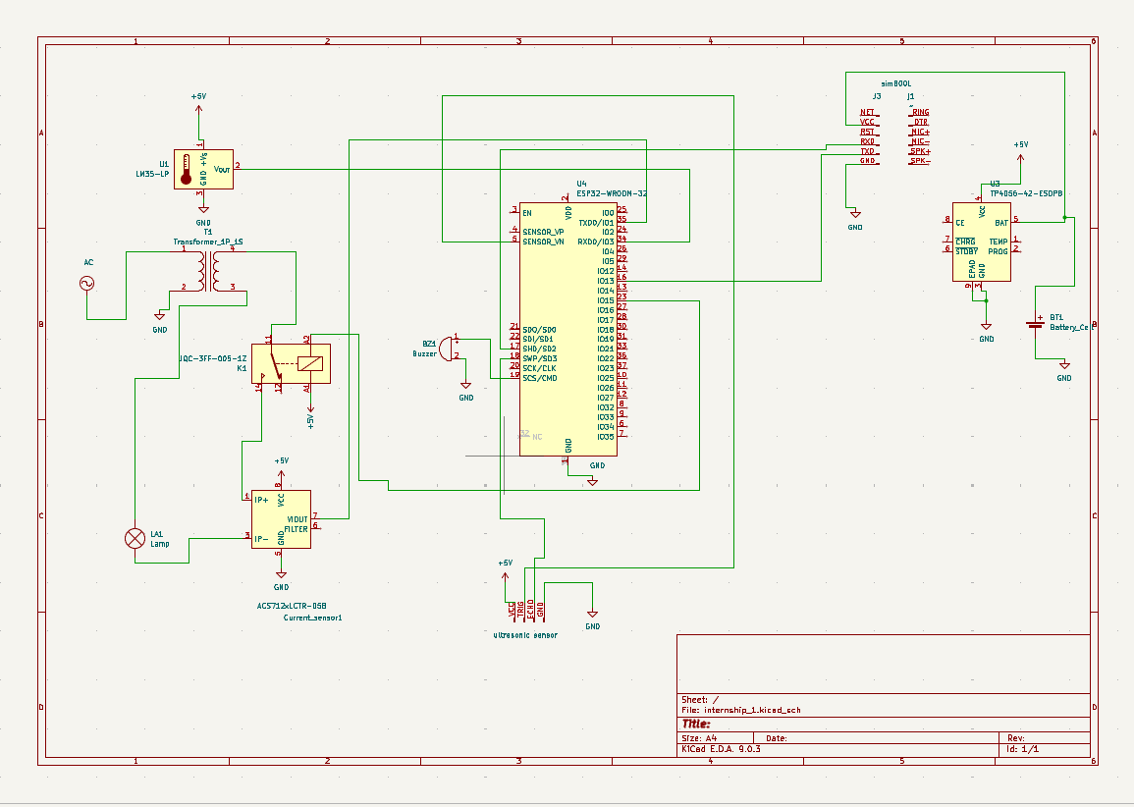

Fig 5.2. Complete Circuit Schematic of ESP32-Based Monitoring System

5.4 Software Implementation
The system software was developed using Platform IO. The ESP32 reads data from sensors, processes the values, and compares them with predefined threshold values.
The software performs:
- Sensor data acquisition
- Data conversion into physical values
- Threshold comparison
- Fault detection
- Relay and buzzer control
- SMS sending through GSM
- Cloud communication via Wi-Fi
The program runs continuously in loop mode to ensure uninterrupted monitoring.

5.5 Data Processing and Communication
In this stage, sensor data collected by ESP32 is transmitted to cloud platforms. Wi-Fi communication is used to send live data to Blynk and ThingSpeak servers.
The communication includes:
- Real-time data transmission
- Cloud storage
- Remote monitoring
- Fault message generation
This ensures real-time system response and data availability.

  - Sensor Data Conversion and Mathematical Formulation
- Calculation for Temperature Sensor:
The LM35 temperature sensor produces an output voltage proportional
to temperature. The output voltage increases linearly with temperature at a rate
of 10 mV per °C.
V= (ADC×3.3​) / 4095
Temperature = V * 100

- Calculation for Current Sensor:
The ACS712 (20A) sensor produces an analog voltage proportional to current. At zero current, the output voltage is 2.5 V
V= (ADC×3.3​) / 4095
Sensitivity = 100 mV/ A
Current = (V – 2.5 ) / Sensitivity;

- Calculation for oil level (Ultrasonic Sensor)
The ultrasonic sensor measures the time taken for ultrasonic waves to travel to the oil surface and return.
- The distance is calculated using the formula:
Distance = Time × Speed of Sound ÷ 2
Speed of sound in air is 343 m/s.
- The oil level is calculated as:
Oil Level = Tank Height − Measured Distanc

5. 7 Threshold Detection Logic
Threshold values were defined to identify abnormal transformer conditions. The system compares measured values with predefined safe limits.
Typical threshold values used:
Parameters | Threshold Values
Temperature | 40
Current | 0.8
Oil level | 10
Table 5.7.1 : Threshold Values
If any parameter exceeds its threshold value:
- Relay disconnects load
- Buzzer activates
- GSM sends SMS alert
This prevents transformer damage.

- Usage of Modern engineering tools
The successful development and implementation of the Smart Transformer Health Monitoring System using ESP32 relied on the use of various modern engineering tools and technologies for efficient circuit development, programming, testing, and real-time monitoring. The key tools used during the internship are as follows:
- ESP32 Development Board:
The ESP32 microcontroller was used as the main processing unit of the system. It collected data from sensors such as LM35 temperature sensor, ACS712 current sensor, and float oil level sensor, and processed the data for monitoring and control operations.
- PlatformIO IDE (Embedded Development):
PlatformIO integrated with Visual Studio Code was used for writing, compiling, and uploading Embedded C/C++ programs to the ESP32. It provided efficient debugging tools and library management, making the development process faster and more reliable.
- ThingSpeak (Cloud Platform):
ThingSpeak was used for storing sensor data on the cloud. It enabled visualization and maintenance of historical data records such as temperature, current, and oil level, which helped in analyzing transformer performance over time.
- Blynk (IoT Monitoring Platform):
Blynk was used to create a real-time monitoring dashboard that displayed transformer parameters remotely. It allowed users to monitor system performance and receive alerts through a mobile interface.
- GSM SIM800L Module:
The GSM SIM800L module was used to send SMS notifications during abnormal conditions such as overheating, overcurrent, or low oil level. This improved system safety by providing instant alerts.
- Telegram Bot (IoT Notification Platform):
The Telegram Bot was used to send real-time alerts and notifications to users during abnormal transformer conditions. The ESP32 transmitted warning messages such as overtemperature, overcurrent, and low oil level using the Telegram Bot API through Wi-Fi. This enabled remote monitoring of transformer health from any location. It improved system reliability by providing instant and cost-effective fault alerts.
- Visual Studio Code (Integrated Development Environment):
Visual Studio Code was used as the primary development environment. It provided useful features such as debugging tools, code formatting, and extensions that supported efficient program development using PlatformIO.
- Digital Multimeter and Testing Tools:
A digital multimeter and other testing tools were used to measure voltage, current, and continuity during circuit testing. These tools helped in troubleshooting connections and verifying the proper working of sensors and modules.
- Outcome/ results of internship work (screenshots of work done)

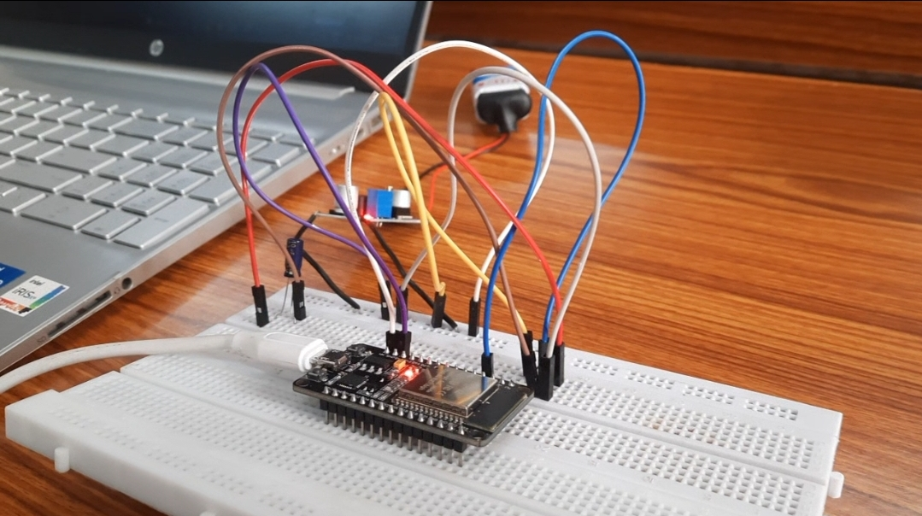

Fig 7.1 Breadboard testing of the sensor

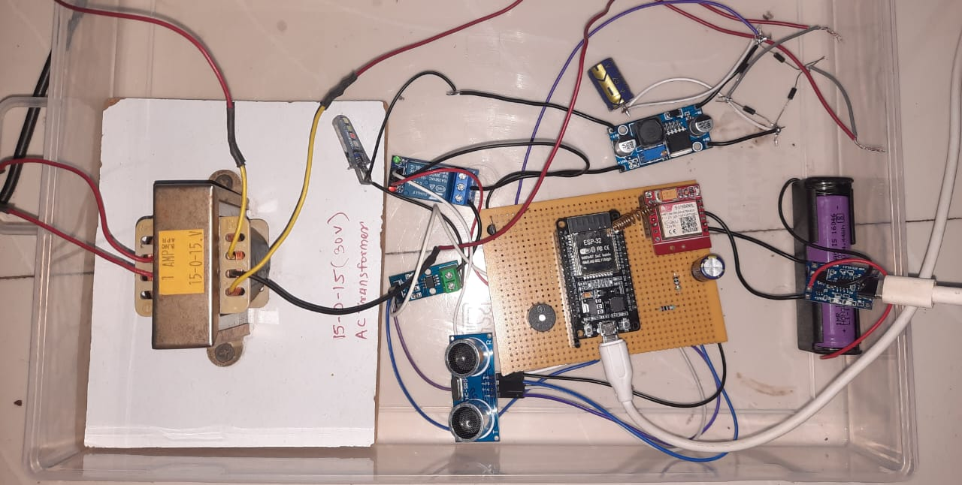
Fig 7.2 : Hardware Prototype of IoT-Based Transformer Health Monitoring System

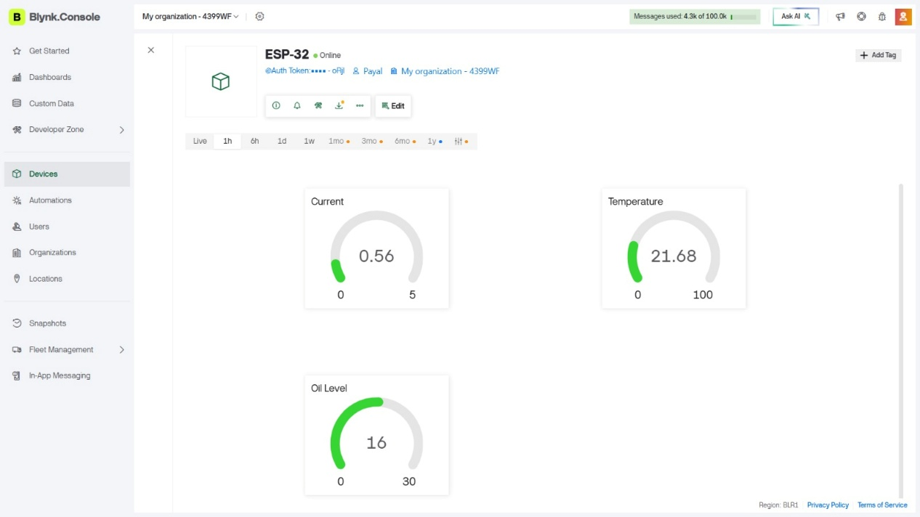

Fig 7.3: Live Monitoring on the Blynk app

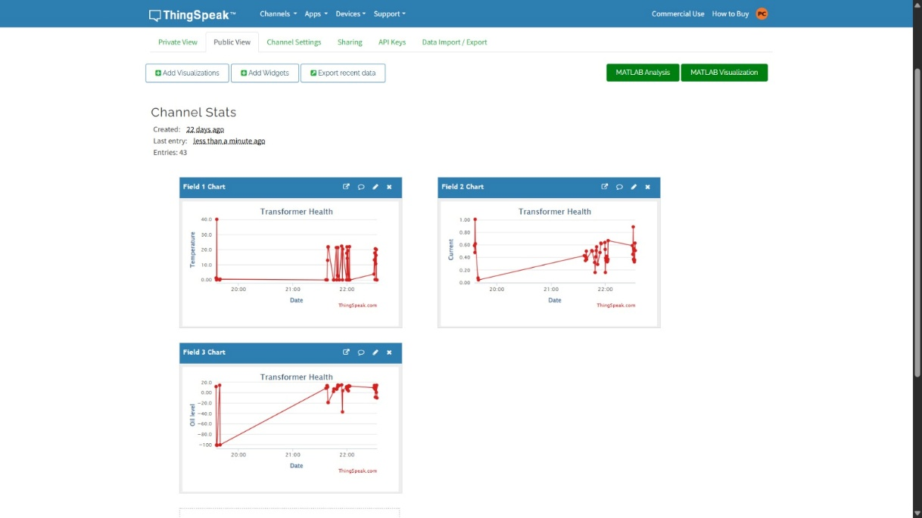
Fig 7.4 : ThingSpeak Cloud Dashboard Showing Transformer Health Parameters

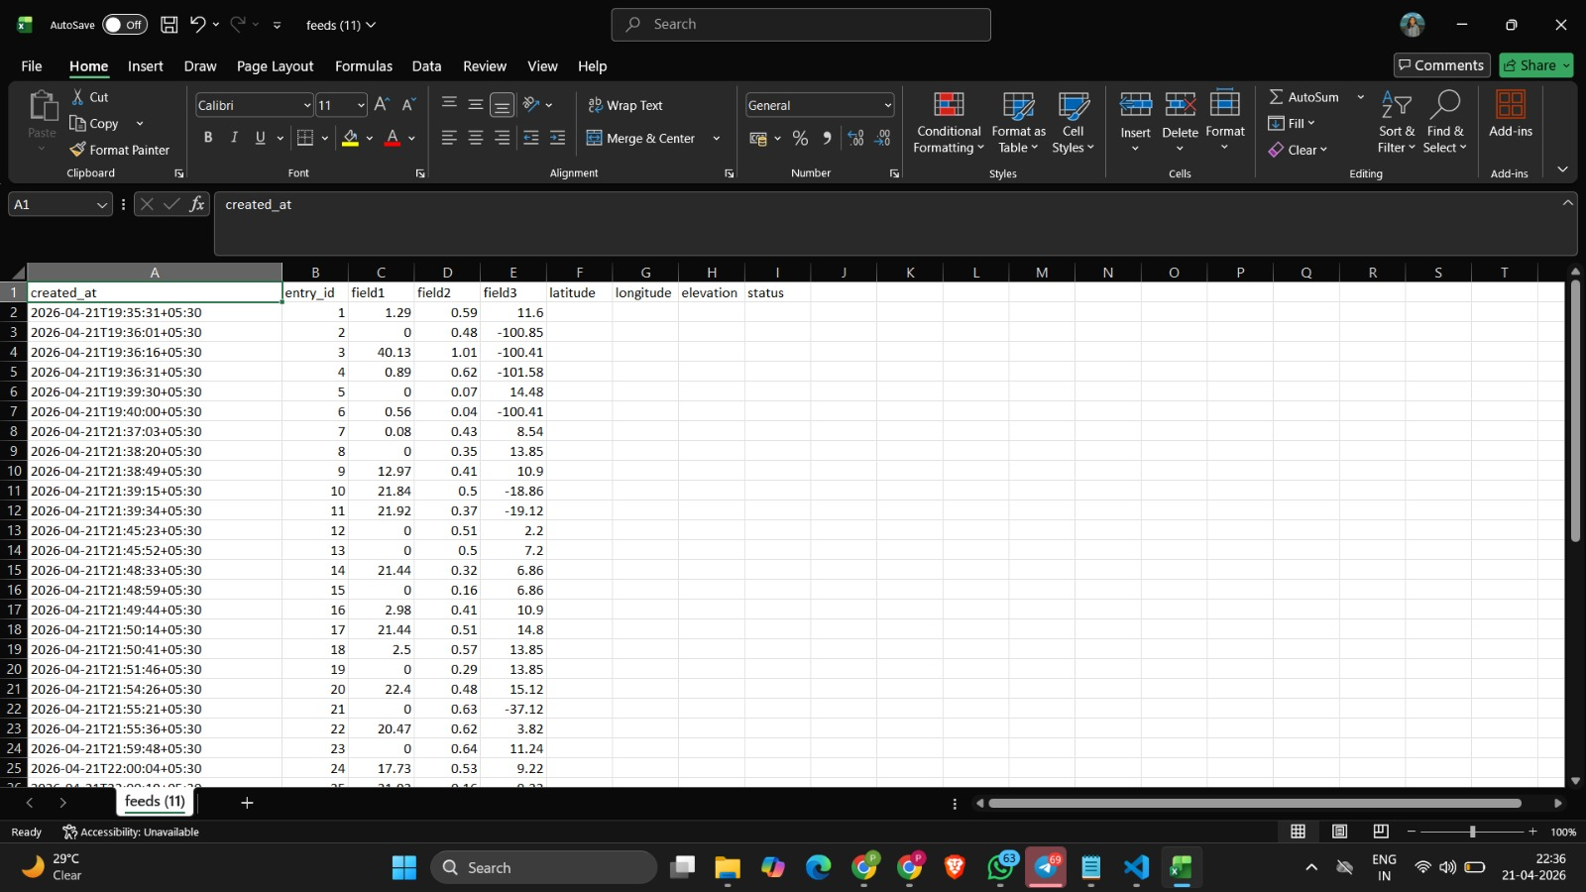

Fig 7.5: Historical Transformer Parameter Data Stored Excel Export

